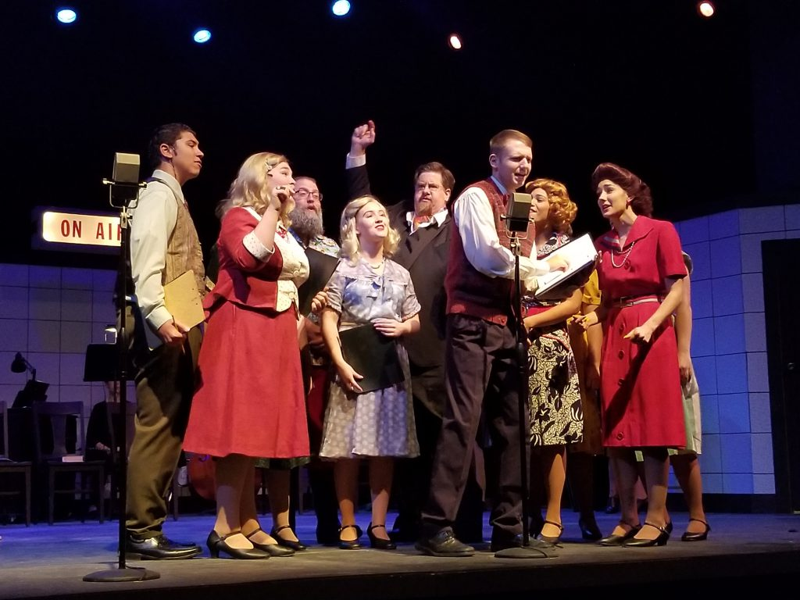

**MVc’s Theatre productions**

-------------------------------------

auditions

Antigone

-------------------------------------

**wednesday, 10/07**

**aT 8:00PM**

**Majors and non-majors are welcome**

The Eckilson-Mabee Theatre

Missouri Valley College

|  |  |
| --- | --- |
|  |  |